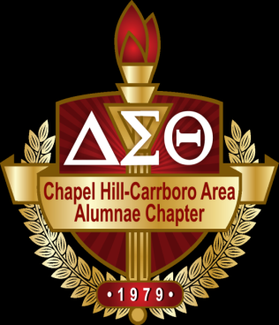

TO: Orange and Chatham County High School Seniors

FROM: Chapel Hill Carrboro Area Alumnae Chapter of
Delta Sigma Theta Sorority, Inc.

DATE: January 17, 2020

The Chapel Hill-Carrboro Area Alumnae Chapter of Delta Sigma Theta Sorority, Inc. will award non-renewable scholarships in the amounts of $500-$1000 for general scholarships and one (1) $2,500 for the Ishna J. Hall Memorial Scholarship to deserving Africa American high school female or male seniors who will graduate from area high schools in Orange and Chatham counties this 2019-2020 school year. Recipients must attend an accredited college or university in the fall of 2020. Selection of recipients is based on the following criteria:

1. Students applying for the Ishna J. Hall Memorial Scholarship ($2,500) requirements:
1. An official sealed transcript showing the required cumulative grade point average of at least an
3.5 weighted or 3.0 un-weighted and a combined SAT score of 1000 or above or an ACT
composite of 22 or above.

2. Two references: One Teacher and One Community Member

3. Two (2) well-written /typed essay of 300 words or less which clearly and completely details
answers to the questions provided.

2. Students applying for a General Scholarship ($500-$1000) requirements:
1. An official sealed transcript showing required cumulative grade point average of at least 2.5 or
above and a combined SAT score of 900 or above or an ACT composite of 20 or above.

2. Two references: One Teacher and One Community Member

3. A well-written/typed essay of 300 words or less which clearly and completely details answers
to the question provided.

The deadline for submitting all information is Friday, February 21, 2020. The application and all required information must come in one packet, first class U.S. mail (please no certified mail that requires a signature). Information received after February 21, 2020 will disqualify the applicant.

If you have any additional questions, please feel free to contact Ms. Ann Wilkerson at cawdst@att.net
The application and the letter to the seniors are located on our website: www.chcaa-dst.org, under “Scholarship.”

Chapel Hill-Carrboro Area Alumnae Chapter
DELTA SIGMA THETA SORORITY, INC.

A Public Service Sorority
Founded 1913

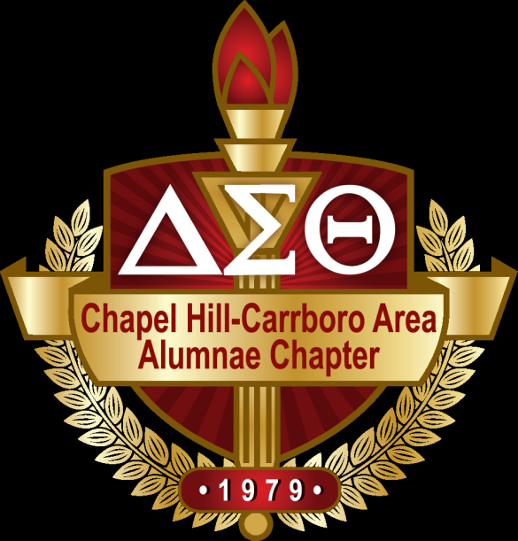

“Intelligence is the Torch of Wisdom”

2019-2020 SCHOLARSHIP APPLICATION

POSTMARKED BY February 21, 2020

Chapel Hill-Carrboro Area Alumnae Chapter
Delta Sigma Theta Sorority, Inc.
P. O. Box 3411
Chapel Hill, N. C. 27515

Scholarship Committee

Ann Wilkerson, Chair Hazel Gibbs, Co-Chair
Phone: 919-265-3947 JoAnn McClelland, Co-Chair

Application Process

The Chapel Hill-Carrboro Area Alumnae Chapter of Delta Sigma Theta Sorority, Inc. will award scholarships to graduating African American high school female and male seniors. Students who attend the following Orange and Chatham County high schools are eligible to apply:

Carrboro High School East Chapel Hill High School
Cedar Ridge High School Jordan Matthews High School
Chapel Hill High School Northwood High School
Chatham Central High School Orange High School

Criteria: Students who desire to apply for a scholarship must meet the following criteria.
  - African-American female or male student.
  - Plan to attend a 2 or 4-year institution of higher learning in the United States in the 2020-2021 school year.
  - Achieve a minimum high school unweighted GPA (Grade Point Average) of 3.5-2.5 or better on a 4.0 scale.
  - Participate in extra-curricular and/or public service activities
  - Participate in the interview process
  - Well written/typed essay; topic provided

Award: Scholarships (multiple) are to be awarded in the amounts of $500 to $1000 non-renewable (General Scholarship)
$2,500 (one) nonrenewable (Ishna J. Hall Memorial Scholarship ONLY).

Application Portfolio Postmarked By February 21, 2020
The Complete Application Packet must include:
.
- A completed application ((typed or legibly written)

- Two (2) Letters of Recommendation (typed or legibly written)
- Two letters of recommendation from a classroom teacher and a community service supervisor attesting to character, academic achievement, leadership, and community service. Well documented evidence/proof of community service activities with at least 23 service hours. References will not be accepted from relatives or members of the scholarship committee. The letters should be sealed and signed across the seal of the envelope by the recommender. They must be included in your application packet.

- Typed Essay (limited to one single-spaced page in 12 point font)

1. General Scholarship Essay Topic ONLY: 1 Essay -The essay must be attached as indicated to the cover page of your
application packet.

2. Ishna J. Hall Memorial Scholarship Essay Topics; 2 Essay Topics required - the General Essay Topic and the Ishna J.
Hall Memorial Scholarship Topic. Both essays must be attached as indicated to the cover page of your application packet.

- Academic Transcript
Your official high school transcript must be included in your packet. It must be in an envelope that has been signed by your Guidance Counselor across the sealed back flap of the envelope.

- Interview
Interviews for final consideration for the scholarship will be held on Saturday, March 21, 2020. All applicants may not be interviewed. Only those selected for final consideration will be interviewed. If you are selected to be interviewed, you will be notified by telephone or email of the interview location and scheduled time during the week of March 18-22, 2020.

- Must bring a Photo ID when interviewed. Interview date March 21, 2020. Location TBA
Please mail your completed application packet along with the academic transcript all together to:
Chapel Hill-Carrboro Area Alumnae Chapter
Delta Sigma Theta Sorority, Inc.
c/o Scholarship Committee
P.O. Box 3411
Chapel Hill, NC 27515
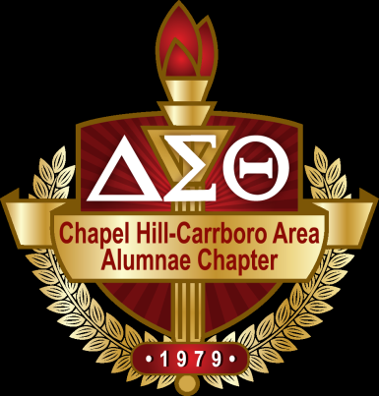
SCHOLARSHIP APPLICATION

Chapel Hill–Carrboro Area Alumnae Chapter
Delta Sigma Theta Sorority, Inc., Inc. founded in 1913, has the largest black sorority membership in the U.S.A.

Ishna J. Hall Memorial Scholarship _________ General Scholarship ____________

Personal Data

Name ___________________________ Email Address ___________________________

Date of Birth ________________________ Phone Number ( ) _______________

Current Residence____________________________________________________________________________
Street City Zip

Name(s) of Parent(s) or Guardian________________________________________________

Number of Siblings Who Reside in the Household _____ Brothers_____ Sisters _____

Educational Data

School Presently Attending_______________________________________________

School Address___________________________________________________________________
Street City Zip

Grade Point Average (Grade 9 through First Semester of the Senior Year) ____________ ___________
Un-Weighted
Weighted

SAT Scores___________ ___________ ___________ ACT Score_________
Critical Reading Math Writing Score
___________ ___________ ____________ _________
Date Taken Date Taken Date Taken Date Taken

College or University Which You Plan to Attend________________________________

Address____________________________________________________________________________________
Street City/State Zip

Counselor’s Name _________________________ Counselor’s Phone # ___________________________

Student Activity Information

Directions: Please complete each section. DO NOT BE MODEST. All information can be used by the Scholarship Committee during the selection process.

Extra-Curricular Activity | Description | Leadership Position Held | Length of Service

Community Activities

Directions: List community activities in which you have participated, (Church groups, volunteer organizations, clubs, community art endeavors, etc.). The activities in which you engage must be completed outside of school.
Community Service Activity | Description | Length of Service

Work Experience

Place of Employment | Description of Responsibilities | Dates

Recognition & Awards

Directions: List any honors and recognition that you have received (Grades 9 - 12).

Award/Recognition | Grade(s)

References

Directions: Two letters of reference are required. One must come from a teacher, and one must come from a church member, community member, or an employer. References from relatives will not be considered. Letters of reference should address the following:

Character
Personality
Motivation
Initiative
Sense of Responsibility
Citizenship

Essays

Essay One – Ishna J. Hall Memorial Scholarship Applicant ONLY: Separate sheet- Typed 300 words
Describe a Community Service Project that you were involved in that had a significant impact on your community? What leadership role did you have in the planning and the implementation of this service project?

Essay Two – (REQUIRED) for both Scholarship Applicants. Separate sheet – Typed 300 words
As you have been observing recent national events related to racial issues, share your thoughts about your role in improving racial relationships in your community and the larger society. What are three specific things you could do or suggest to do to improve racial relationships in your community and the larger society?

Application and requested documents must be received by Friday, February 21, 2020. The application and all required information must come in one packet, first class U.S. mail (please no certified mail return receipt request). Information received after February 21, 2020 will disqualify the applicant.

Direct complete application packet which includes application, transcript, letters of reference, essays, to:
Chapel Hill-Carrboro Area Alumnae Chapter
Delta Sigma Theta Sorority, Inc.
Attention: Ann Wilkerson
P.O. Box 3411
Chapel Hill, NC 27515
Blank

